Introduction to the White Rust of Crucifers:
White rust or white blisters disease is one of the common diseases of crucifer crops. It is worldwide in distribution occurring in all the areas wherever crop is cultivated. Both wild and cultivated varieties are attacked.
The disease affects a large number of crucifer crops of economic importance like Mustard, Cress, Rape, Radish, Cabbage, Cauliflower, turnip etc. In India the disease is reported on Mustard, Rape, Eruca sativa, turnip. Cauliflower and Cleome viscosa.
Effect of White Rust Disease:
Although considered unimportant in proportion to its widespread occurrence, the disease may cause serious damage in certain areas and the losses may be upto 25 percent when the floral parts get malformed and seeds are not formed at all.
The disease in association with downy mildew disease of crucifers caused by Peronospora parasitica cause severe damage to the crop.
Symptoms of White Rust Disease:
The disease affects all the aerial parts of the plant, the roots are not attacked. Symptoms may appear as a result of two types of infection: Local and Systemic.
In case of local infection, isolated spots or pustules appear on leaves or stems or inflorescence. The pustules are of variable size, measuring 1 -2 mm in diameter and are raised shiny white areas.
These may arise in close proximity and coalesce to form large irregular patches. Usually, the pustules appear in circular or concentric arrangement with one or two central areas. The host epidermis ruptures exposing white powdery mass consisting of spores of the fungus. Pustules occurring on leaves are usually confined to the lower surface only.
In systemic infections, young stems and inflorescence are infected. The fungus becomes systemic in these parts and the affected tissues are stimulated to various types of deformities. The most prominent is Hypertrophy of the affected parts. Due to Hypertrophy and Hyperplasia of floral parts, these show swellings and distortion.
The peduncle and pedicel may become enormously thickened upto 12-15 times, the normal diameter. Floral parts become fleshy, swollen, green or violet in colour, the stamens falling off early.
The petal may turn green sepal like and stamens and carpels are also converted to swollen leaf like structures. The ovules are usually atrophied as also the pollen grains resulting in total sterility. Pustules may also appear on these parts. However, the affected parts are full of oospores and starch.
When the systemic infection has taken early, the growth of the entire plant is checked, stunted and only small leaves may be formed.
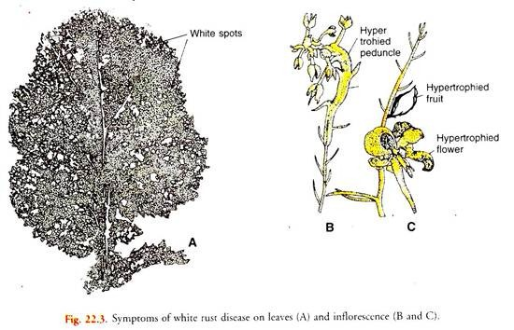
The stem and the axis of the inflorescence may get twisted appearing in a zigzag sequence. Normal dormant buds are stimulated and grow into lateral shoots.
Causal Organism:
The causal organism Albugo candida (Lev.) Kunze or Cystopus candidus Lev. is an obligate parasite.
Disease Cycle:
The primary infection occurs due to oospores perennating in the soil or due to mycelium perennating on perennial hosts. These serve as primary inoculum when the environmental conditions are favourable.
Oospores germinate in presence of water to form a vesicle in which a large number of zoospores are formed. These zoospores swim in a film of water and land on the suitable host, germinate by germ tubes, enter the host and establish infection. The mycelium in the host is intercellular with globose haustoria.
Soon the mycelium after absorbing nutrients and food materials from the host, accumulates below the lower epidermis. Conidiophores, which are clavate, and formed at the tip of hyphae, begin to produce conidiosporangia in basipetal succession. The pressure of these breaks open the lower epidermis and white rust symptoms become apparent on the leaves.
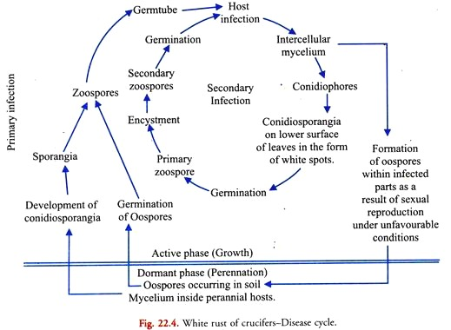
The conidiosporangia produced during early phase of the growing season cause secondary infection in the host. These are blown away by wind or any other agency, land on the host surface and germinate to form zoospores.
The zoospores germinate by formation of germ tubes which enter the host and cause secondary infection. If the conditions are favourable, this is repeated.
When the conditions become unfavourable or during the later phase of the growing season, the fungus begins sexual reproduction producing oospores. These oospores, being thick-walled, can withstand the unfavourable conditions.
During harvesting of the crop, the diseased hypertrophied portions of the plant are generally left in the field where they perennate waiting for the favourable conditions to return back.
Control Measures of White Rust Disease:
The disease may be controlled by the following methods:
(i) Clean cultivation and destruction of weed should be practised.
(ii) Crop rotation will avoid the soil borne primary inoculum.
(iii) Spraying with 0.8 percent Bordeaux mixture or Dithane M-45 (0.2%) may be undertaken to check the spread of the disease.
(iv) Disease resistant varieties be preferred.

